FUN-FILLED FAMILY MOMENTS WORTH PAYING FOR WITH MISSING LINK

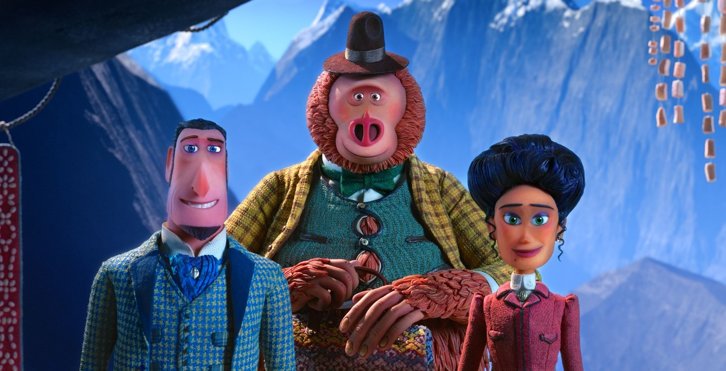

Things are about to get hairy as Lionsgate’s animated adventure of legendary proportions, Missing Link bounds onto the big screen this April. From the award winning LAIKA studios, this fun-filled family film is the latest to receive an exclusive trailer as part of the Industry Trust’s Moment Worth Paying For campaign, to combat film piracy.

The trailer features brand new, never seen before footage, showcasing the hilarious and heart-warming moments in the film and reminding families that sharing unforgettable moments all together at the cinema, are always moments worth paying for.

Hugh Jackman is Sir Lionel frost: a brave and dashing adventurer who considers himself to be the world’s foremost investigator of myths and monsters. The trouble is, no one else seems to agree. He sees a chance to prove himself by traveling to America’s Pacific Northwest to discover the world’s most legendary creature. A living remnant of Man’s primitive ancestry. The Missing Link.
Zach Galifianakis is Mr. Link: the slightly silly, surprisingly smart and soulful beast who Sir Lionel discovers. As species go, he’s as endangered as they get; he’s possibly the last of his kind, he’s lonely, and he believes that Sir Lionel is the one man alive who can help him. Together they set out on a daring quest around the world to seek out Link’s distant relatives in the fabled valley of Shangri-La.
Along with the independent and resourceful Adelina Fortnight (Zoe Saldana), who possesses the only known map to the group’s secret destination, the unlikely trio embarks on a riotous
rollercoaster ride of a journey. Along the way, our fearless explorers encounter more than their fair share of peril, stalked at every turn by dastardly villains seeking to thwart their mission. Through it all, Mr. Link’s disarming charm and good-humoured conviction provide the emotional and comedic foundation of this fun-filled family movie.
The Industry Trust’s consumer education campaign continues to deliver the core message – inspiring audiences to choose the big screen experience. Like the others in the Moments Worth Paying For series, the trailer directs audiences to the industry-funded film search engine, FindAnyFilm.com, which signposts legal content sources, so they can book, buy and watch at their convenience.
Simon Dunstan -Senior Promotions Manager, Lionsgate UK “We have a longstanding history in partnering with the Industry Trust on their exclusive Moments Worth Paying For trailer and we’re delighted that “Missing Link” will be the latest film featured in this incredibly important initiative that encourages cinema goers to experience movies as intended. Missing Link, from LAIKA studios is a lavish, stylish adventure for the whole family to enjoy in cinemas this Easter. “

Sylvia Dick, Head of Audience Engagement, The Industry Trust said: “In recent years, developments in technology have created new ways for audiences to infringe. Illicit streaming devices (ISD’s) have exposed an increased number of parents to pirated film & TV content, a third of whom have children under 10. Therefore working with Lionsgate on an incredibly fun and family spirited title like Missing Link is extremely important for us, as the aim of the campaign is to highlight the movie-going experience as a shared activity which truly is worth paying for.”

Missing Link is released in UK cinemas on 5th April 2019

Press Contact:

Louiza Manson
Tel: 0203 397 3969 or email: louiza@grapevinedigital.com

Notes to Editors
About The Industry Trust for IP Awareness
The Industry Trust is the UK film, TV and video industry’s consumer education body, promoting the value of copyright and creativity. Its consumer awareness programmes address the on-going challenge of film and TV copyright infringement by inspiring audiences to value great movie moments and choose to watch film, TV and video via legitimate sources. Industry funded, their work aims to engage three distinct audience groups: young people, 16-34-year-old men; and parents, providing extensive insight around audience attitudes and understanding of intellectual property. For more information on the Industry Trust’s work, visit www.industrytrust.co.uk.

About FindAnyFilm.com
FindAnyFilm.com is one of the UK's leading websites for film fans looking to book, buy and watch films and TV programmes. Operated by The Industry Trust for IP Awareness, the website offers 122,000 films and TV shows across all formats, from cinema to DVD and Blu-ray, as well as download and streaming services. Visitors can search by title and talent, and can sort their results by format and price.

About Lionsgate UK
Lionsgate U.K. is the diversified U.K.-based filmed entertainment arm of Lionsgate (NYSE:LGF), a premier next generation global content leader with a diversified presence in motion picture production and distribution, television programming and syndication, home entertainment, international distribution and sales, branded channel platforms, interactive ventures and games, and location-based entertainment. The company (formerly Redbus Film Distributors) was acquired by Lionsgate in October 2005 and has since established a reputation in the U.K. as a leading producer and distributor and acquirer of commercially successful and critically acclaimed product, recently releasing the 6 time BAFTA and OSCAR winning “LA LA LAND”, the BAFTA and OSCAR winner “HACKSAW RIDGE, Noel Clarke’s “BROTHERHOOD”, the crowd pleaser “EDDIE THE EAGLE”, the multi award winning “BROOKLYN”, the BAFTA Nominated “SICARIO”, and blockbuster “LONDON HAS FALLEN”. Upcoming titles for the 2016/7 slate include Lone Scherfig’s “THEIR FINEST”, “POWER RANGERS” and Luc Besson’s Sci-Fi Comic Book adaptation “VALERIAN AND THE CITY OF A THOUSAND PLANETS”.

The company’s home entertainment business is an industry leader in box office-to-DVD and box office-to-VOD revenue conversion rates. Lionsgate handles a prestigious and prolific library of approximately 16,000 motion picture and television titles that is an important source of recurring revenue and serves as a foundation for the growth of the Company's core businesses. The Lionsgate and Summit brands remain synonymous with original, daring, quality entertainment in markets around the world. www.lionsgatefilms.co.uk

