EXPERIENCE THE EPIC ADVENTURE OF SONY PICTURES’
GHOSTBUSTERS: AFTERLIFE IN CINEMAS

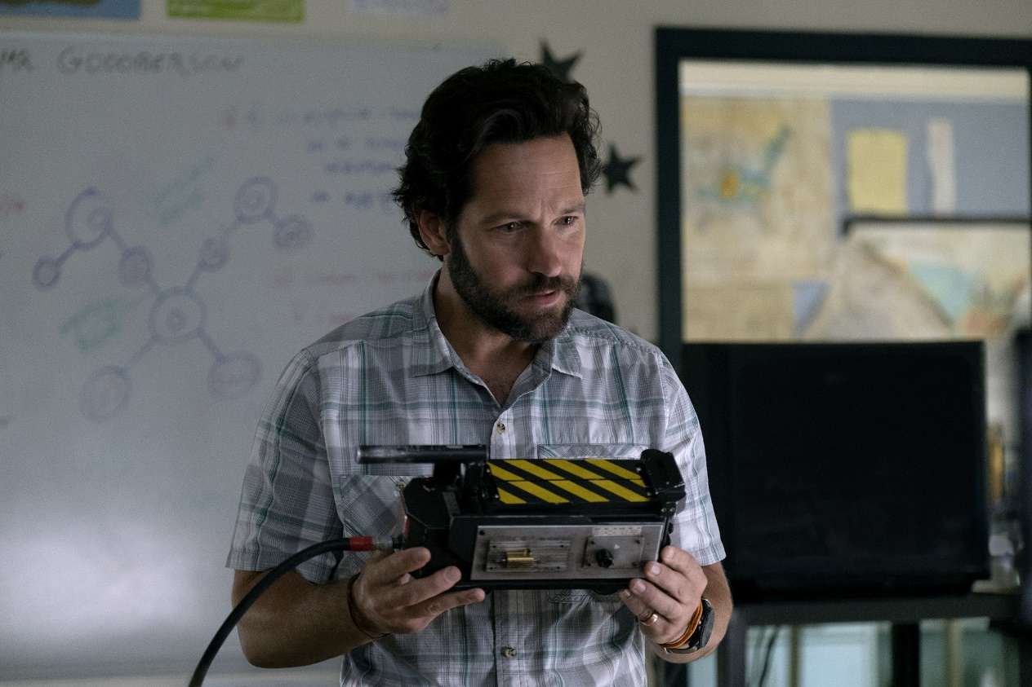

Sony Pictures’ highly-anticipated Ghostbusters: Afterlife is the latest film to receive a trailer for Industry Trust’s Moments Worth Paying For campaign ahead of its release across the U.K. and Ireland in cinemas on 18th November 2021.

In support of the campaign, a special Ghostbusters: Afterlife clip was created that features the cast encouraging fans to experience the epic adventure on the big screen. From the ultimate nostalgia fix, to action and new discoveries, these unforgettable movie moments are best seen in the highest quality, taking audiences to the Ghostbusters universe where they can unfold the legacies left behind from past characters.

The special clip will screen in cinemas and online and can be viewed here.

From director Jason Reitman and producer Ivan Reitman, comes the next chapter in the original Ghostbusters universe. In Ghostbusters: Afterlife, when a single mom and her two kids arrive in a small town, they begin to discover their connection to the original Ghostbusters and the secret legacy their grandfather left behind. The film is written by Gil Kenan & Jason Reitman.

Based on the 1984 film “Ghostbusters,” an Ivan Reitman film written by Dan Aykroyd and Harold Ramis, Ghostbusters: Afterlife is produced by Ivan Reitman and executive produced by Dan Aykroyd, Gil Kenan, Jason Blumenfeld, Michael Beugg, Aaron L. Gilbert, Jason Cloth and stars Carrie Coon, Finn Wolfhard, Mckenna Grace, Annie Potts, and Paul Rudd.

Liz Bales, Chief Executive, The Industry Trust for IP Awareness said: “The new Moments Worth Paying For trailer presents a warm welcome back to cinema from the cast of Ghostbusters: Afterlife, the perfect message for our second campaign in 2021! The new trailer reminds us that cinema is the best way to experience the biggest new films, and audiences agree – the latest Industry Trust insights confirm that families are keen to return to the big screen this year. Tapping into the nostalgia of the Ghostbusters franchise, we hope this campaign resonates with viewers young and old, and continues to inspire them to support the industry by paying to watch the content they love. The Moments Worth Paying For campaign is truly back with a bang, and I look forward to the exciting slate of clips set for 2022!”

Ian George, Managing Director, U.K. & Ireland, Sony Pictures Releasing International said: “Once again we are delighted to be partnering with The Industry Trust on this terrific clip for Ghostbusters: Afterlife. The film is full of heart and adventure, and will delight audience of all ages. We recognise the importance of campaigns such as this to ensure the movie-goer understands the link between their support and our on-going ability to provide content that is of such high quality.”

Like the others in the Moments Worth Paying For series, the trailer directs audiences to the industry-funded film search engine, FindAnyFilm.com, which signposts legal content sources, so they can book, buy and watch at their convenience.

###
Media Contacts
For all media enquiries please contact
Alice.Goodger@Alfredlondon.com

Notes to Editors

About The Industry Trust for IP Awareness
The Industry Trust is the UK film, TV and video industry’s consumer education body, promoting the value of copyright and creativity. Its consumer awareness programmes address the on-going challenge of film and TV copyright infringement by inspiring audiences to value great movie moments and choose to watch film, TV and video via legitimate sources. Industry funded, their work aims to engage three distinct audience groups: young people, 16-34-year-old men; and parents, providing extensive insight around audience attitudes and understanding of intellectual property. For more information on the Industry Trust’s work, visit www.industrytrust.co.uk.

About FindAnyFilm.com
FindAnyFilm.com is one of the UK's leading websites for film fans looking to book, buy and watch films and TV programmes. Operated by The Industry Trust for IP Awareness, the website offers 122,000 films and TV shows across all formats, from cinema to DVD and Blu-ray, as well as download and streaming services. Visitors can search by title and talent, and can sort their results by format and price.

