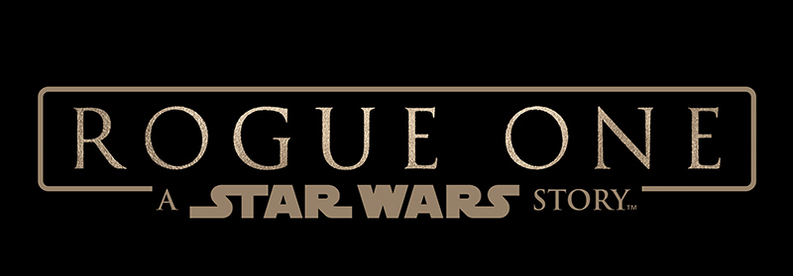

DISNEY, LUCASFILM AND THE INDUSTRY TRUST JOIN FORCES ONCE AGAIN

ROGUE ONE: A STAR WARS STORY ACTRESS FELICITY JONES INSPIRES AUDIENCES TO CHOOSE CINEMA IN NEW TRAILER FOR IP AWARENESS

LONDON. 25^{h} November 2016. The Industry Trust for IP Awareness, The Walt Disney Company and Lucasfilm announce a new collaboration on the first Star Wars standalone film, Rogue One: A Star Wars Story.

The campaign launches today with a 35” exclusive trailer featuring British actress Felicity Jones, who plays protagonist and Rebel leader Jyn Erso in the latest highly anticipated release from Lucasfilm. Jones speaks directly to camera to deliver Industry Trust’s Moments Worth Paying For anti-piracy message, encouraging audiences to experience the best that movies have to offer in the cinema.

Jones lends her voice to The Industry Trust’s consumer education campaign for the first time, inspiring audiences to choose cinema and enjoy all those great movie moments worth paying for. Recent research by ICM has identified around three quarters of males aged 16-34 download or stream unauthorised content and more women accessing unauthorised content now than in 2014. Rogue One: A Star Wars Story trailer therefore makes a great addition to the Industry Trust’s 2016 education and awareness campaign, as it appeals to core Star Wars fans and is a part of such an iconic franchise – while attracting a wider audience through the great British talent that is Felicity Jones.

The Rogue One: A Star Wars Story Moments Worth Paying For trailer will show in cinemas from 25th November and will be further supported by activity across outdoor and online (through partners Clear Channel and Primesight), ensuring the Industry Trust’s messaging targets core infringers not only in the cinema but also across other platforms.

Lee Jury, Vice President Marketing. Co-Head of Studios, at The Walt Disney Studios EMEA and UK said: “The Moments Worth Paying For campaign is a great addition to the educational work the Industry Trust does for protecting our film industry. Nearly 40 years ago British creativity brought Star Wars to the big screen and it’s fantastic that British talent in front and behind the camera is set to captivate cinema audiences around the world again with Rogue One: A Star Wars Story. We hope this trailer, featuring Felicity Jones, will inspire film fans to support the films they love and to watch them as they are meant to be seen – on the big screen.”
Sylvia Dick, Head of Audience Engagement at The Industry Trust for IP Awareness said: “Star Wars: The Force Awakens was highly anticipated last year and Rogue One: A Star Wars Story is expected to be just as fantastic. It’s really amazing to be working with Disney and Lucasfilm again and is such a great addition to the Industry Trust’s educational work. We hope the trailer continues to inspire audiences of all ages, male and female, to head to the cinema for everything films have to offer, those moments that are really worth paying for.”

Rogue One: A Star Wars Story will open in UK cinemas on December 15.

- ENDS –
Press Contacts: Lauren Rooney, Public Relations and Social Media Executive, The Industry Trust
Tel: 0207 440 0374 or email: lauren.rooney@industrytrust.co.uk

Notes to Editors
About Rogue One: A Star Wars Story
From Lucasfilm comes the first of the Star Wars standalone films, “Rogue One: A Star Wars Story,” an all-new epic adventure. In a time of conflict, a group of unlikely heroes band together on a mission to steal the plans to the Death Star, the Empire’s ultimate weapon of destruction. This key event in the Star Wars timeline brings together ordinary people who choose to do extraordinary things, and in doing so, become part of something greater than themselves.

“Rogue One: A Star Wars Story” is directed by Gareth Edwards and stars Felicity Jones, Diego Luna, Ben Mendelsohn, Donnie Yen, Mads Mikkelsen, Alan Tudyk, Riz Ahmed, with Jiang Wen and Forest Whitaker. Kathleen Kennedy, Allison Shearmur and Simon Emanuel are producing, with John Knoll and Jason McGatlin serving as executive producers. “Rogue One: A Star Wars Story” opens in UK cinemas on 15th December, 2016.

About The Industry Trust for IP Awareness
The Industry Trust is the UK film, TV and video industry’s consumer education body, promoting the value of copyright and creativity. Its consumer awareness programmes address the on-going challenge of film and TV copyright infringement by inspiring audiences to value great movie moments and choose to watch film, TV and video via legitimate sources. Industry funded, their work aims to engage three distinct audience groups: young people, 16-34-year-old men; and parents, providing extensive insight around audience attitudes and understanding of intellectual property. For more information on the Industry Trust’s work, visit www.industrytrust.co.uk
About FindAnyFilm.com
FindAnyFilm.com is one of the UK's leading websites for film and TV fans looking to watch, buy, download, stream or rent legitimate film and TV. Operated by the Industry Trust for IP Awareness, the website offers 117,000 films and TV programmes across all formats, from cinema to disc, and digital. Visitors can search by title and talent, and view results by format and price.

