
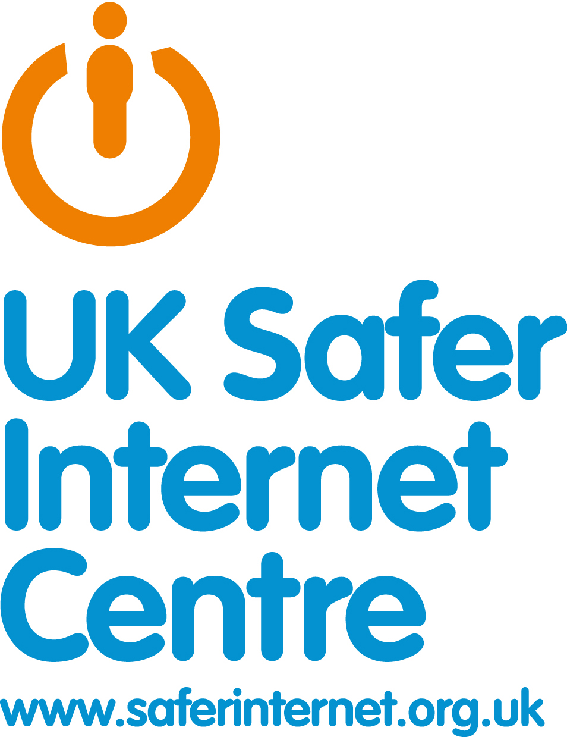
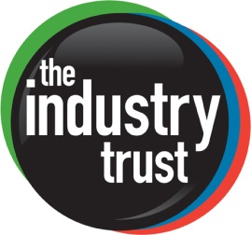

THE INDUSTRY TRUST & INTO FILM LAUNCH CHILDREN’S INTERNET SAFETY CAMPAIGN AHEAD OF UK SAFER INTERNET DAY 2018

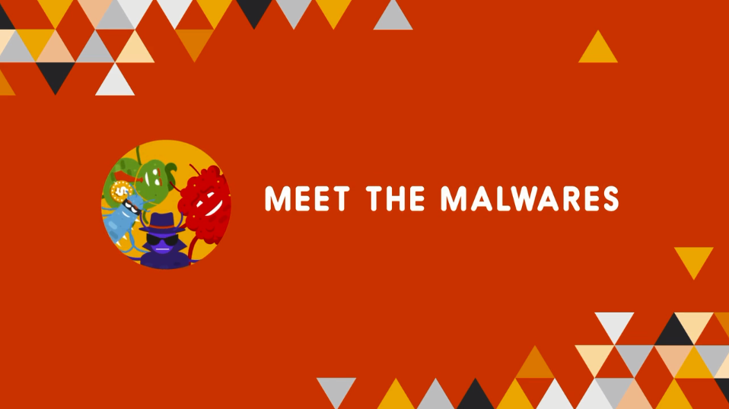

London. Tuesday 6th February, 2018: The Industry Trust for IP Awareness, in partnership with film education charity, Into Film, has today launched “Staying Safe Online - Meet the Malwares”, a short animation and educational resource aimed at teachers and young people, ahead of UK Safer Internet Day 2018.

The educational resource is intended for use in schools to engage with children aged 7-14 to underline how to stay safe online (when accessing film and TV content), whilst also developing their understanding of the different types of malware and their effects, including webcam hacks, the leak of personal data and online blackmail. This is supported by the “Meet the Malwares” animation which highlights the different types of virus that can affect a user’s computer or personal device.

Into Film’s Young Reporter Network provided the voices for the different characters in the Meet the Malwares animation, with the accompanying teaching resource including case studies detailing the all too real scenarios that young people can experience when it comes to the unwanted sharing of private images and online extortion.

The launch coincides with UK Safer Internet Day which offers the opportunity to highlight positive uses of technology and explore the role we all play in helping to create a better and safer online community. It calls upon young people, parents, carers, teachers, social workers, law enforcement, companies, policymakers, and the wider community, to join together in helping to create a better internet.

Liz Bales, Chief Executive of The Industry Trust for IP Awareness states: “With many years of expertise, from designing and delivering engaging IP education programs, we are adamant that ‘Staying Safe Online – Meet The Malwares’ will be a captivating and enjoyable learning resource for both students and teachers. We hope that it helps to teach young people that copyright infringement can lead to some very serious consequences. With recent research showing that more and more young people are exposed to explicit content and even hacking as a result of malware, we’re excited to be launching this content in association with Into Film and UK Safer Internet Day to help further boost our message.”

Paul Reeve, Chief Executive Officer of Into Film says: “Online safety is a key issue for schools now that children are gaining access to the internet from a young age, but it can be a tricky subject to teach. ‘Meet the Malwares’ tackles the issues in a way that will engage children, and will support teachers to explain the potential dangers of being online. We are really proud of this project and look forward to working more with Childnet and Safer Internet Day to raise the profile of this important topic in schools across the UK”.

Will Gardner, CEO Childnet, Director of the UK Safer Internet Centre, says: “I’m delighted to see the collaboration between The Industry Trust and Into Film taking shape in the form of a brand new educational resource and accompanying animation, detailing the threat malware can cause whilst accessing pirated material online. Whether you are a young person, parent, carer, school or organisation, there are steps that each person can take to make the internet a safer place. It is collaborations such as these which help to ensure Safer Internet Day has the desired positive outcome, especially as it reached 42% of UK children in 2017 and is growing year on year. To have two of the UK’s leading organisations in their respected fields come together speaks volumes about the importance of the day and I look forward to seeing this resource being made available for use in classrooms across the UK.”

-Ends-

‘Meet The Malwares’ Animation

Embed Code

<iframe src="https://player.vimeo.com/video/250091868?title=0&byline=0&portrait=0" width="640" height="360" frameborder="0" webkitallowfullscreen mozallowfullscreen allowfullscreen></iframe>
<p><a href="https://vimeo.com/250091868">Meet the Malwares</a> from <a href="https://vimeo.com/user18102163">Into Film</a> on <a href="https://vimeo.com">Vimeo</a>.</p>

Download Link

https://www.dropbox.com/s/pf2kw2qhnvaseu0/MTM%20FINAL.mov?dl=0

Notes to editors

For Further Information, please contact;

- Andy Neilson, Public Relations & Social Media Executive - 0207 440 0374 andy@baseorg.uk

- Jenny Davis, Communications Manager - 0207 440 1586
Jenny.Davis@industrytrust.co.uk

- Sarah Wilby, Senior PR and Editorial Officer, Into Film -0330 313 7873
Sarah.wilby@intofilm.org

About The Industry Trust for IP Awareness:
The Industry Trust is the UK film, TV and video industry’s consumer education body, promoting the value of copyright and creativity. Its consumer awareness programmes address the on-going challenge of film and TV copyright infringement by inspiring audiences to value great movie moments and choose to watch film, TV and video via legitimate sources. Industry funded, their work aims to engage three distinct audience groups: young people, 16-34-year-old men; and parents, providing extensive insight around audience attitudes and understanding of intellectual property. For more information on the Industry Trust’s work, visit www.industrytrust.co.uk.

About Into Film:

Into Film is an education charity that puts film at the heart of children and young people’s educational, cultural and personal development.
Over half of UK schools engage with a programme of Into Film Clubs, special cinema screenings, and resources and training to support classroom teaching. Alongside rich online content for young audiences, this provides 5-19 year olds with inspiring opportunities to learn about and with film, and develop a passion for cinema.–
Into Film’s work is supported principally by the BFI with National Lottery funding, and by the film industry through Cinema First. www.intofilm.org

About the BFI:

The BFI is the lead body for film in the UK with the ambition to create a flourishing film environment in which innovation, opportunity and creativity can thrive by:
- Connecting audiences to the widest choice of British and World cinema
- Preserving and restoring the most significant film collection in the world for today and future generations
- Championing emerging and world class filmmakers in the UK – investing in creative, distinctive and entertaining work
- Promoting British film and talent to the world
- Growing the next generation of filmmakers and audiences

The BFI is now a Government arm’s-length body and distributor of Lottery funds for film. The BFI serves a public role, which covers the cultural, creative and economic aspects of film in the UK. It delivers this role:
- As the UK-wide organisation for film, a charity core funded by Government
- By providing Lottery and Government funds for film across the UK
- By working with partners to advance the position of film in the UK.

Founded in 1933, the BFI is a registered charity governed by Royal Charter.
The BFI Board of Governors is chaired by Josh Berger, CBE

About Safer Internet Day:
Safer Internet Day 2018 will be celebrated globally on Tuesday 6th February with the slogan ‘Create, Connect and Share Respect: a better internet starts with you.’ Coordinated in the UK by the UK Safer Internet Centre the celebration sees hundreds of organisations get involved to help promote the safe, responsible and positive use of digital technology for children and young people.

The UK Safer Internet Centre – a partnership of three leading charities; Childnet, SWGfL (South West Grid for Learning) and the Internet Watch Foundation – provide resources for children, schools and families, and tools for getting involved at www.saferinternet.org.uk.

Globally, Safer Internet Day is celebrated in more than a hundred countries, coordinated by the joint Insafe/INHOPE network, with the support of the European Commission, and national Safer Internet Centres across Europe.

