DAZZLING MOVIE MOMENTS WORTH PAYING FOR
WITH ENTERTAINMENT ONE’S STAN & OLLIE

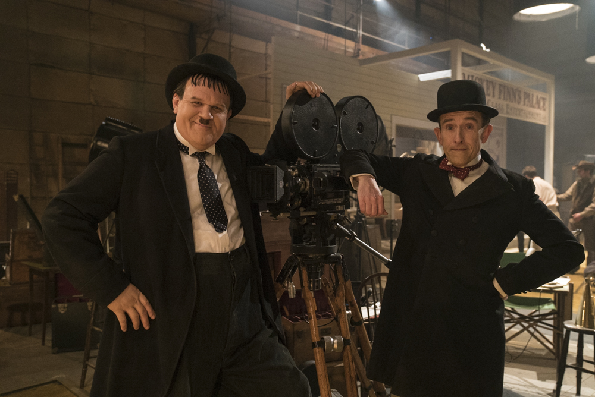

It’s time to don your bowler hat as Entertainment One have teamed up with the Industry Trust’s Moments Worth Paying For campaign to bring you an exclusive trailer for the spectacular, touching drama about the dazzling double act STAN & OLLIE.

Co-stars Steve Coogan and John C. Reilly, who play homage to two of cinemas greats in the film, present the trailer discussing all the all the great reasons to enjoy going to the cinema. From comfy seats, to endless snack options, the duo decide it’s experiencing unforgettable moments all together that makes watching films worth paying for.

The true story of Hollywood’s greatest comedy double act, Laurel and Hardy, is brought to the big screen for the first time. Starring Steve Coogan and John C. Reilly as the legendary movie icons, Stan & Ollie is the heart-warming story of what would become the pair’s triumphant farewell tour.

With their golden era long behind them, the duo embark on a variety hall tour of Britain and Ireland. Despite the pressures of a hectic schedule and with the support of their wives Lucille (Shirley Henderson) and Ida (Nina Arianda), their love of performing, as well as for each other, endures as they secure their place in the hearts of their adoring public.

The Industry Trust’s consumer education campaign continues to deliver the core message – inspiring audiences to choose the big screen experience. Like the others in the Moments Worth Paying For series, the trailer directs audiences to the industry-funded film search engine, FindAnyFilm.com, which signposts legal content sources, so they can book, buy and watch at their convenience.

James Gallagher, Senior Marketing Manager, The Industry Trust said: “We couldn’t be happier in joining forces with Entertainment One to deliver another unforgettable Moments Worth Paying For trailer. Having comedy icons Steve Coogan and John C. Reilly on board along with their trademark wit and charm, helps spread the message that the biggest stars deserve the biggest screen. It’s important that the Moments campaign can be tailored to appeal to all age groups and we hope that this partnership works to highlight that films are best enjoyed in cinemas in the company of friends and family, instead of turning towards piracy. It’s a testament to the campaign and it’s inspirational message that we’re able to continue securing A-list talent in order to inspire audiences to choose official film and TV.”

Chris Besseling, Head of Marketing – Film at Entertainment One UK said: “Entertainment One remains fully committed to the continued efforts of The Industry Trust to tackle copyright infringement and we are delighted to be collaborating with them again on the release of Stan & Ollie. Working closely with The Trust on its development, we are really pleased to have been able to deliver an exclusive bespoke piece of content for their latest Moments Worth Paying For campaign featuring the film’s stars Steve Coogan and John C. Reilly. A funny and very powerful movie that tells the unknown story of the world’s greatest comedy duo, this is a perfect partnership that celebrates the heritage and importance of the silver screen experience. We hope that this partnership will work to deliver the Industry Trust’s important and inspiring message, highlighting that the magic of the movies is best enjoyed on the big screen together with friends, family and other film lovers.”

Entertainment One’s Stan & Ollie comes to UK cinemas on January 11, 2019.

Press Contacts: Louiza Bennett or Sheena Patel
Tel: 0203 397 3969 or email: louiza@grapevinedigital.com / sheena@grapevinedigital.com

Notes to Editors
About The Industry Trust for IP Awareness
The Industry Trust is the UK film, TV and video industry’s consumer education body, promoting the value of copyright and creativity. Its consumer awareness programmes address the on-going challenge of film and TV copyright infringement by inspiring audiences to value great movie moments and choose to watch film, TV and video via legitimate sources. Industry funded, their work aims to engage three distinct audience groups: young people, 16-34-year-old men; and parents, providing extensive insight around audience attitudes and understanding of intellectual property. For more information on the Industry Trust’s work, visit www.industrytrust.co.uk.

About FindAnyFilm.com
FindAnyFilm.com is one of the UK's leading websites for film fans looking to book, buy and watch films and TV programmes. Operated by The Industry Trust for IP Awareness, the website offers 122,000 films and TV shows across all formats, from cinema to DVD and Blu-ray, as well as download and streaming services. Visitors can search by title and talent, and can sort their results by format and price.

About Entertainment One Ltd.
Entertainment One Ltd. (LSE:ETO) is a global independent studio that specialises in the development, acquisition, production, financing, distribution and sales of entertainment content. The Company’s diversified expertise spans across film, television and music production and sales, family programming, merchandising and licensing, and digital content. Through its global reach and expansive scale, powered by deep local market knowledge, the Company delivers the best content to the world.
Entertainment One’s robust network includes film and television studio The Mark Gordon Company; content creation venture Amblin Partners with Steven Spielberg, DreamWorks Studios, Participant Media, and Reliance Entertainment; leading feature film production and global sales company Sierra Pictures; unscripted television production companies Renegade 83, Paperny Entertainment and Force Four Entertainment; world-class music labels Dualtone Music Group and Last Gang; and award-winning digital agency Secret Location.
The Company’s rights library is exploited across all media formats and includes more than 100,000 hours of film and television content and approximately 40,000 music tracks.
www.entertainmentone.com

