SHAUN THE SHEEP FLOCKS TO THE CINEMA WITH MOMENTS WORTH PAYING FOR TRAILER

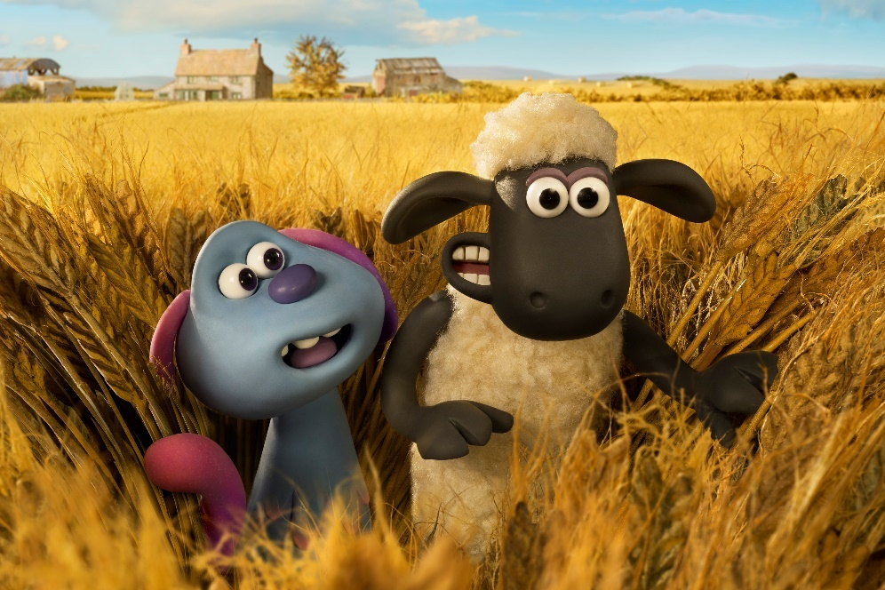

Prepare for lift-off as Shaun is back for his biggest adventure yet in, A Shaun the Sheep Movie: Farmageddon. Ahead of its October release, the film will feature in an exclusive trailer for the Industry Trust’s Moments Worth Paying For campaign.

The trailer features bespoke animation showing Shaun the Sheep flocking to the cinema and championing the value of film on the big screen. From the snacks, the comfy seats and the incredible first encounters - the trailer aims to show audiences that the cinema is the best place to enjoy “out of this world movie moments” and that these are moments worth paying for. Like others in the Moments Worth Paying For series, the trailer directs audiences to the industry-funded film search engine, FindAnyFilm.com, which signposts legal content sources, so consumers can book, buy and watch movies at their convenience.

In A Shaun the Sheep Movie: Farmageddon strange lights over the quiet town of Mossingham herald the arrival of a mystery visitor from far across the galaxy. When the intergalactic guest – an impish and adorable alien called LU-LA – crash-lands near Mossy Bottom Farm, Shaun soon sees an opportunity for alien-powered fun and adventure and sets off on a mission to shepherd LU-LA home. Her magical alien powers, irrepressible mischief and galactic sized burps soon have the flock enchanted. However, when Shaun takes his new extra-terrestrial friend on the road to Mossingham Forest to find her lost spaceship, he is unaware that a sinister alien-hunting agency is on their trail. Can Shaun and the flock avert Farmageddon on Mossy Bottom Farm before it’s too late?

Sylvia Dick, Head of Audience Engagement, The Industry Trust said: “Being a stop motion animation, Shaun the Sheep Movie: Farmageddon takes a long time to make with animators working weeks to simply create a couple of minutes of footage, so we have been incredibly lucky and are very grateful to work with both Aardman and StudioCanal on the creation of this fantastic bespoke content. With the latest research showing us that more and more young people are turning to infringement than ever before, using well-known characters such as Shaun the Sheep allows us to speak directly to families and children, helping them choose the right experience when it comes to TV and film content, and steering them away from piracy.”

Stuart Henderson, Head of UK Marketing, StudioCanal said: “It’s a real pleasure to be working with the Industry Trust on this campaign and supporting the invaluable work they do to inspire audiences to enjoy movies on the big screen. With Shaun the Sheep Movie: Farmageddon, the brilliant team at Aardman are taking Shaun and the flock on a hilarious, out-of-this-world adventure and introducing a brilliant new character in the form of LU-LA. This has meant we have had the scope to create a bespoke piece that delivers the Moments Worth Paying For message in an equally playful and inventive way that we believe audiences will really engage with.”

Lucy Wendover, Head of Marketing & Brand, Aardman said: “Our teams dedicate so much time to creating a truly cinematic experience, from story creation through the animation process to vfx and music. Therefore, encouraging audiences to enjoy Shaun the Sheep Movie: Farmageddon at the cinema goes right to the heart of the value that Aardman place on film-making. We are delighted that Shaun and his friends are so expertly helping to deliver the Moments Worth Paying For message!”

A Shaun the Sheep Movie: Farmageddon is released in UK cinemas on 18th October 2019.

- ENDS –

Press Contacts: Louiza Manson
Tel: 0203 397 3969 or email: louiza@grapevinedigital.com

Notes to Editors
About The Industry Trust for IP Awareness
The Industry Trust is the UK film, TV and video industry’s consumer education body, promoting the value of copyright and creativity. Its consumer awareness programmes address the on-going challenge of film and TV copyright infringement by inspiring audiences to value great movie moments and choose to watch film, TV and video via legitimate sources. Industry funded, their work aims to engage three distinct audience groups: young people, 16-34-year-old men; and parents, providing extensive insight around audience attitudes and understanding of intellectual property. For more information on the Industry Trust’s work, visit www.industrytrust.co.uk.

About FindAnyFilm.com
FindAnyFilm.com is one of the UK's leading websites for film fans looking to book, buy and watch films and TV programmes. Operated by The Industry Trust for IP Awareness, the website offers 122,000 films and TV shows across all formats, from cinema to DVD and Blu-ray, as well as download and streaming services. Visitors can search by title and talent, and can sort their results by format and price.

About Studio Canal
STUDIOCANAL, a 100% affiliate of CANAL+ Group held by Vivendi, is Europe’s leader in production, distribution and international sales of feature films and TV series, operating directly in all three major European markets - France, the United Kingdom and Germany - as well as in Australia and New Zealand. STUDIOCANAL owns one of the most important film libraries in the world, boasting more than 6,000 titles from 60 countries. Spanning 100 years of film history, this vast and unique catalogue includes among others the iconic Terminator 2, Rambo, Breathless, Mulholland Drive, The Pianist and Belle de jour. STUDIOCANAL has fully-financed box office hits Tinker Tailor Soldier Spy, Paddington 1 and 2, The Commuter and Shaun The Sheep. Upcoming films backed by STUDIOCANAL include Marjane Satrapi’s Radioactive featuring Rosamund Pike, The Secret Garden produced by David Heyman starring Colin Firth, Aardman Studios’ stop-motion Shaun the Sheep Movie: Farmageddon. STUDIOCANAL is actively developing and distributing high-end TV series through its network of award-winning European production companies, including TANDEM in Germany (Take Two) and the UK’s RED Production Company (Years and Years). STUDIOCANAL is also an associate of Danish-based SAM Productions founded by Søren Sveistrup and Adam Price (Ride Upon The Storm) as well as of UK-based GUILTY PARTY PICTURES; Benedict Cumberbatch’s production company SUNNYMARCH TV (Patrick Melrose); URBAN MYTH FILMS (War of the Worlds) and Spain’s BAMBÚ PRODUCCIONES (Instinto). In 2018, STUDIOCANAL launched a new label in France, STUDIOCANAL ORIGINAL (Mouche).

About Aardman
Aardman, based in Bristol (UK) and co-founded in 1976 by Peter Lord and David Sproxton, is an independent and multi-award-winning studio. It produces feature films, series, advertising, interactive entertainment - such as the ‘visually astonishing’ (The Guardian) console game, 11-11: Memories Retold, and the four-times Gold Cannes Lions-winning StorySign app - and innovative attractions for both the domestic and international market, including a new 4D theatre attraction at Efteling in the Netherlands. Their productions are global in appeal, novel, entertaining, brilliantly characterised and full of charm reflecting the unique talent, energy and personal commitment of the Aardman team. The studio’s work – which includes the creation of much-loved characters including Wallace & Gromit, Shaun the Sheep and Morph – is often imitated, and yet the company continues to lead the field producing a rare brand of visually stunning content for cinema, broadcasters, digital platforms and live experiences around the world. In November 2018 it became an Employee Owned Organisation, to ensure Aardman remains independent and to secure the creative legacy and culture of the company for many decades to come. www.aardman.com

