 

**MOMENTS WORTH PAYING FOR PRESENTS   
A SPECIAL MESSAGE FROM THE CAST OF**

**GRAN TURISMO**

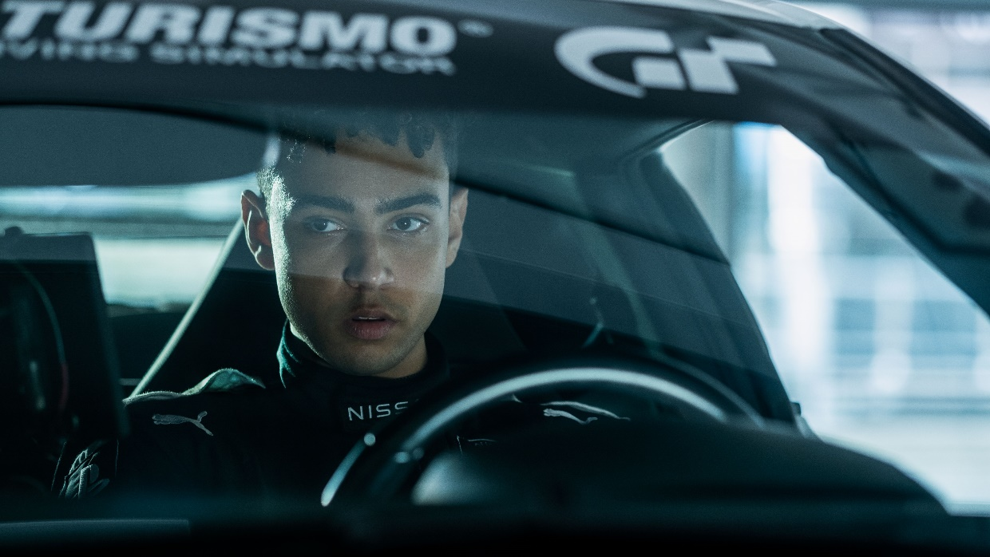

*Watch the video* [*HERE*](https://youtu.be/mnq9cmZE2f4)

*Download the video* [*HERE*](https://base1.box.com/s/2629s1wbmgmuwwu1zkqkpmp5xu47rs3n) *Download images* [*HERE*](https://base1.box.com/s/r6osdejvxe7cnyuki3pwjurffxdtedff)

*Friday 14 July, 2023 –* Start your engines! Today, Moments Worth Paying For presents an exclusive message for UK and Irish audiences from the cast of ***GRAN TURISMO*** ahead of its release only in cinemas on 9 August.

In the exclusive and brand-new content, David Harbour, Orlando Bloom and Archie Madekwe tell audiences why the cinema is the best and only place to catch the blood-pumping adrenaline ride that is ***GRAN TURISMO***.

*Based on the true story of Jann Mardenborough, the film is the ultimate wish fulfillment tale of a teenage Gran Turismo player whose gaming skills won a series of Nissan competitions to become an actual professional racecar driver.*

**Liz Bales**, **Chief Executive** at **British Association *for* Screen Entertainment** said: "Teaming up with Sony Pictures Entertainment for **Gran Turismo** once again spotlights an unparalleled cinematic experience that captivates fans. It’s fantastic to have this amazing group of stars highlight the premium cinema experience in a fun way that fans will love. For over a decade, the Moments Worth Paying For campaign has been at the core of BASE's educational initiatives. By harnessing the collective power of the creative community and collaborating with partners like DCM, Pearl & Dean, and ClearChannel, we remind audiences that films like **Gran Turismo** are best experienced first on the big screen, in cinemas everywhere."

**Ian George**, **Managing Director** at **Sony Pictures Entertainment** said: *“It’s great to work on large-scale films which are meant to be seen on the biggest screen possible. Sony’s new film* ***Gran Turismo*** *is an incredible true story brought into the spotlight by the magic of cinema; in the darkness of an auditorium, you feel every gear change, hear the amazing roar of supercharged engines, and off the road there’s those tender, human moments which fully absorb you in a way no other medium can offer. We are so happy to be working with BASE once again to showcase the value of the big screen experience and encourage friends and families to have a truly unmissable experience in their local cinema this Summer.”*

***Gran Turismo* is released exclusively in UK & Irish cinemas on August 9, 2023.**

Find your nearest screening [here.](https://www.sonypictures.co.uk/movies/gran-turismo)

For further press information about Moments Worth Paying For, please contact  
  
Chris Hagen, Chloe Middlebrook  
[firstname.surname@premiercomms.com](mailto:firstname.surname@premiercomms.com)